INFO1255-23S

**Working in Linux – in class working exercises**

50 Screenshots – 50 points

**Note:** This project is worth 15 marks. ALL screenshots carries the same weight and mark.

This is an **INDIVIDUAL** exercise and screenshots must reflect your won Linux environment.

Save your screenshot **UNDER EACH QUESTION** IN THIS DOCUMENT and upload once the exercise is completed.

Only a screen shot of the Terminal Window is need (not of the entire desktop). It must be large enough and clear enough to easily see the commands or information expected.

**Sample below:**

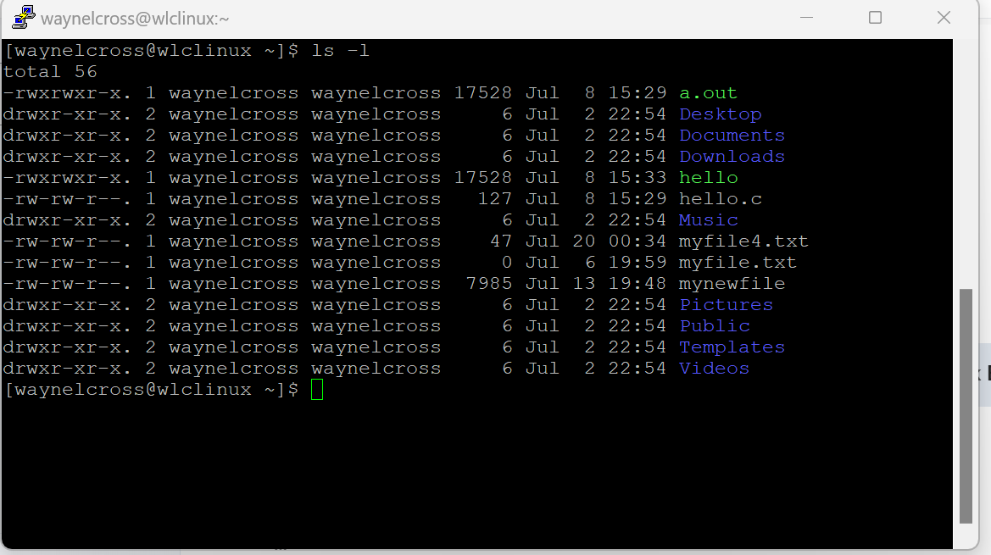

**Name: jay vasani**

**Student ID: 8885487**

**Date: 16 august, 2023**

**START OF EXCERCISE**

**Log into the Linux server using your username.**

1. Create 5 files using the $echo command with some content in each (**take a screen shot of the command)** 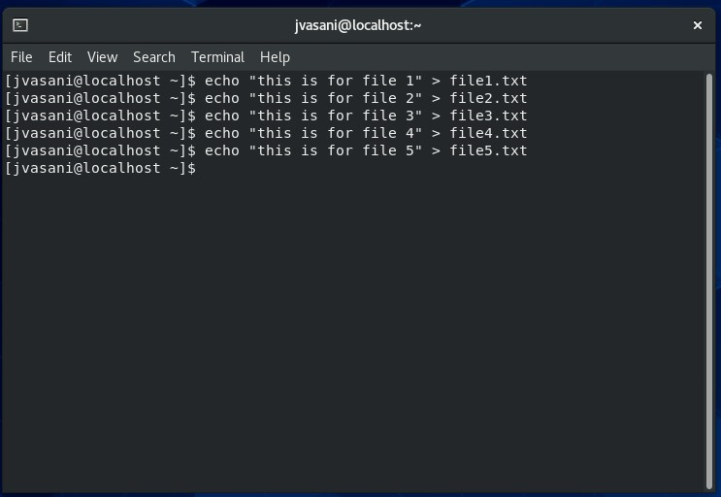
2. Show the content of at least 2 of the files **(take a screen shot)** 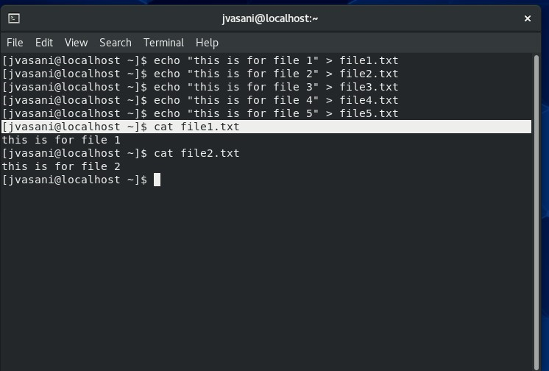
3. List all the files so that the permissions shows : ls -l **( take a screen shot)** 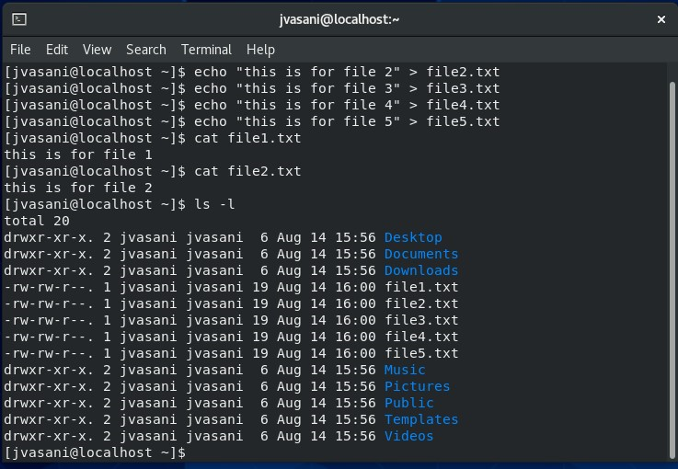
4. Display your current Unmask value : $umask **(take a screenshot)** 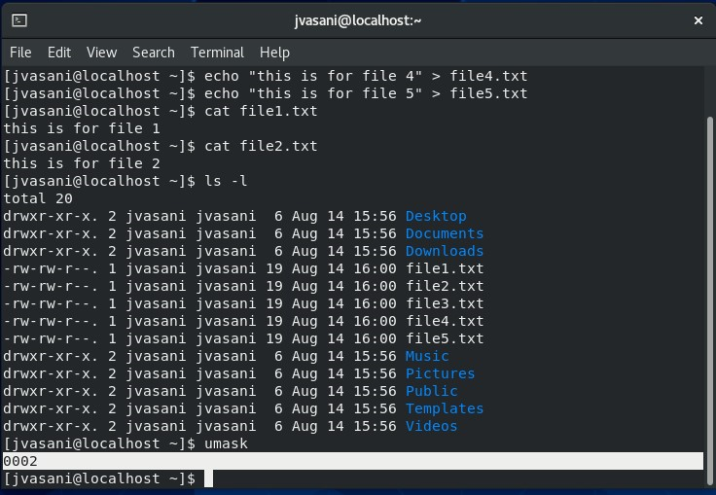
5. Change the permission using RELATIVE mode on one of the file so that ONLY you and your group has Read and eXecute permission, OTHER has NO permission : chmod (**take a screen shot)** 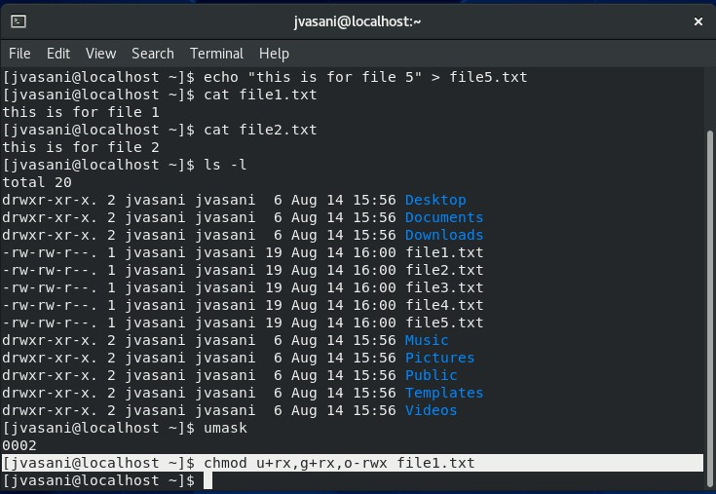

chmoch

1. Change the permission using ABSOLUTE mode on one of the file so that ONLY you have Read and eXecute permission, no one else has permission : chmod **(take a screen shot)** 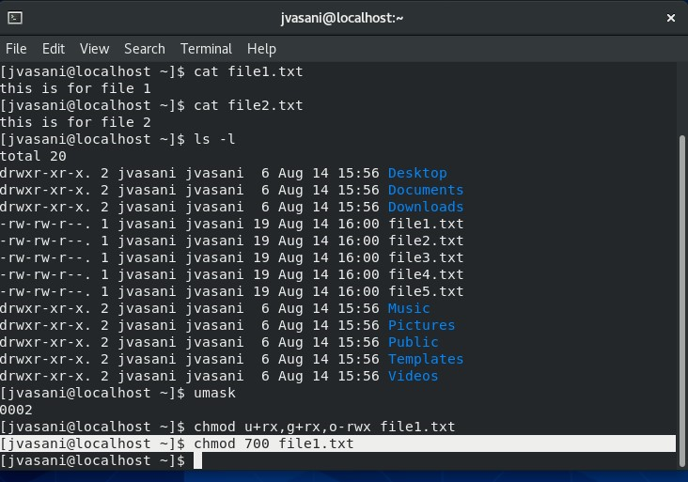
2. Use the command line to create five user accounts. : useradd (**take screenshot)** 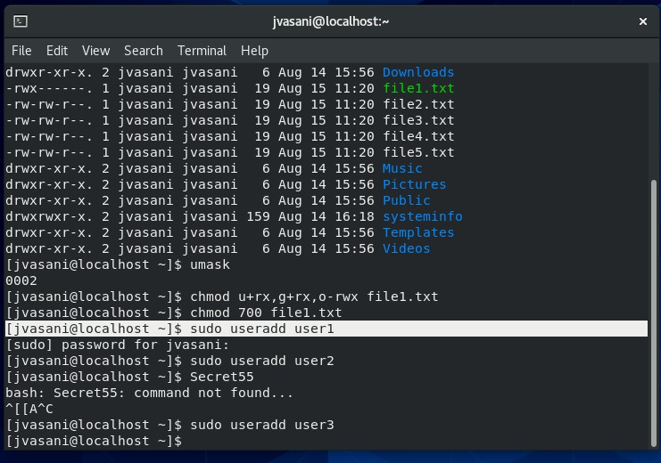id
3. Show the User ID of two of the users : **(take screenshot)** 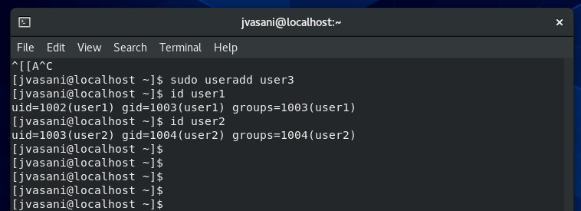
4. Set them all with the same password (for your own sanity). : passwd **(take screenshot)** 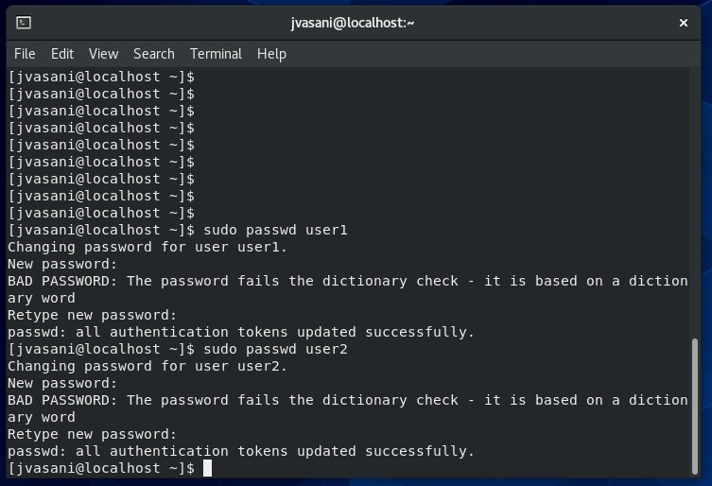
5. Use the command line to create five groups based on fictitious departments: sales, marketing, human resources, IT, engineering. : $groupadd **(take at least 1 screen shot when creating one of the account)** 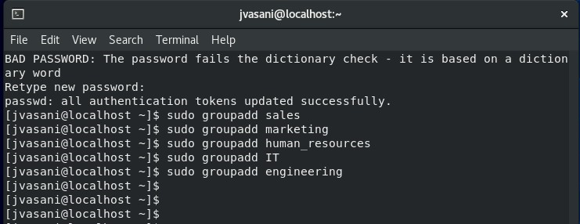
6. Place one user from above into each group. : $usermod **(take screenshot)** 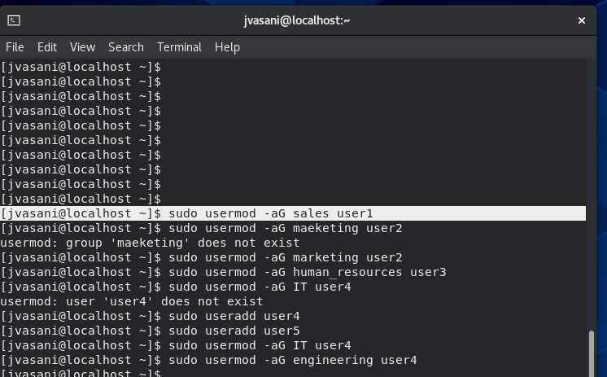
7. Create directories for each of the following department (sales, marketing, human resources, IT, engineering) at the root of the filesystem. $mkdir /sales **(take screenshot)** 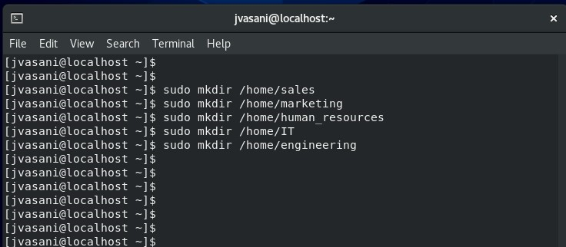
8. Copy two of the files from your home directory (created earlier) into the sales directory using RELATIVE PATH **(take a snapshot)** sudo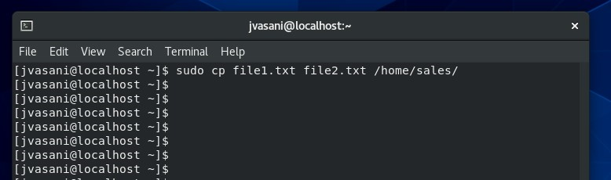
9. Copy the other 3 files from your home directory (created earlier) into the sales directory using ABSOLUTE PATH **(take a snapshot)** 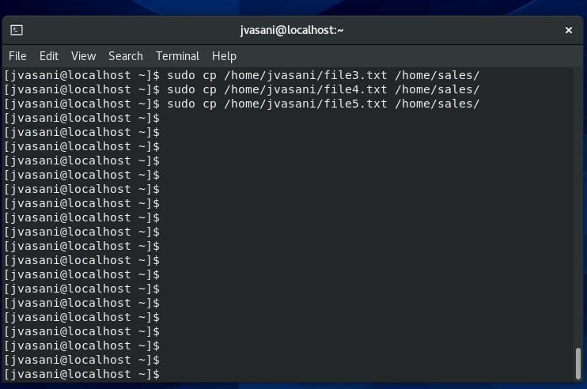
10. Use the $touch command to create 2 more files at one time **(take a screen shot)** 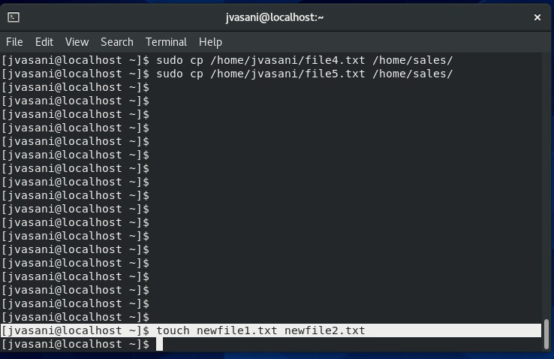
11. Configure standard Linux permissions and ownership such that each group only has access to its own departmental directories. For example, the sales group has access to the /sales directory but not to other departments' directories. $chmod **(take screenshot)** 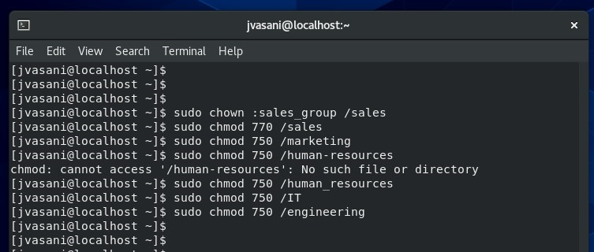
12. Configure ACL permissions to permit the marketing department to have read access to the /sales directory. **(take screenshot)** 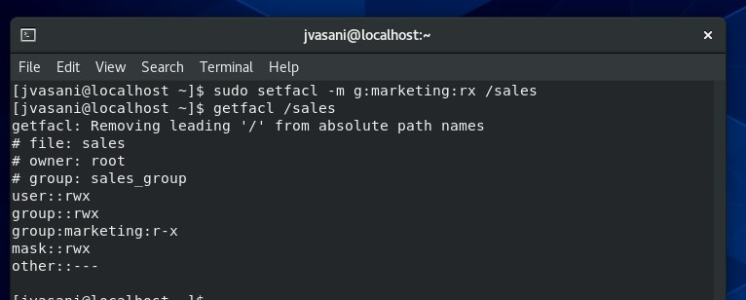
13. Ensure that two of your existing user accounts are now members of the marketing group. **(take screenshot)** 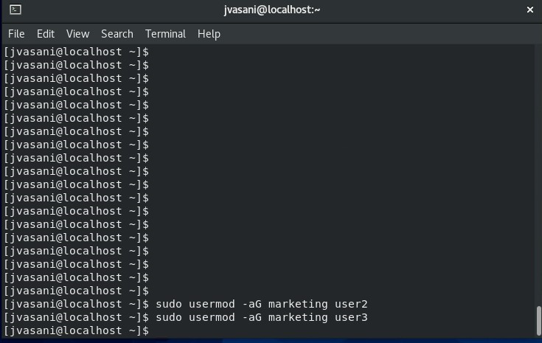
14. Log in using each account in step 18 to create one file in the /marketing director using the $echo command **(take a screen shot)** 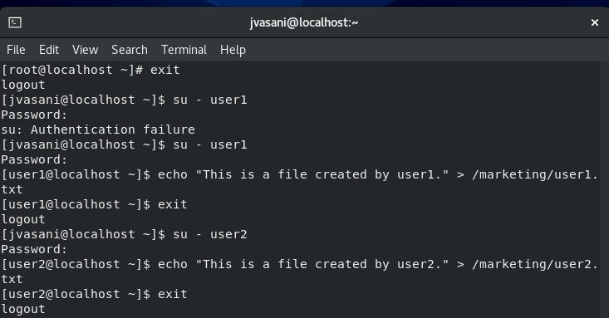
15. **Login back in with your account**



1. Create a file named LinksTest.txt in the /opt directory (you may need to be root) (**take screenshot)** 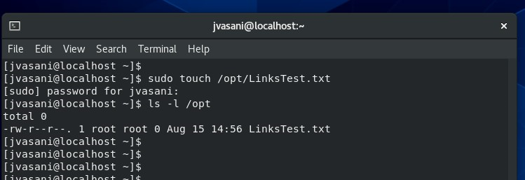
2. Create a hard link to it in the /tmp directory. **(take screenshot)** 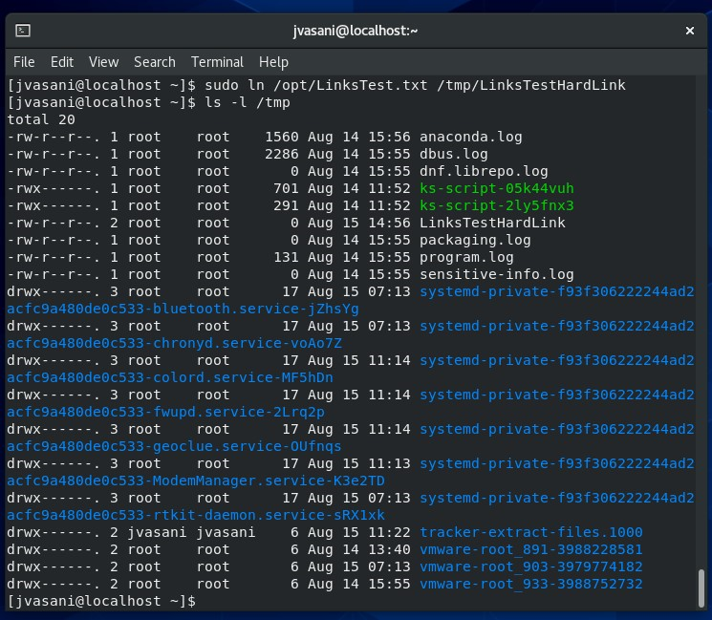
3. **Use Vi to add a line of text to the file through the /opt/LinksTest.txt path,** 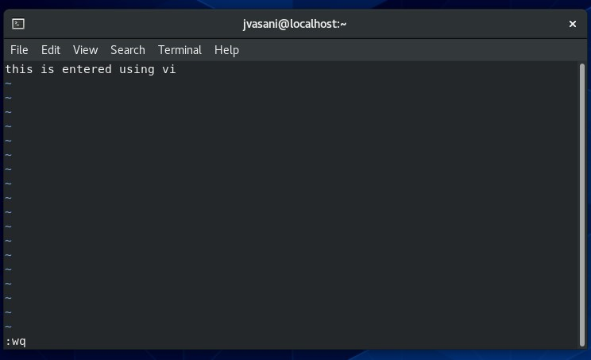
4. Display the file's contents by using the $cat /tmp/LinksTest.txt file path. **(take screenshot)** 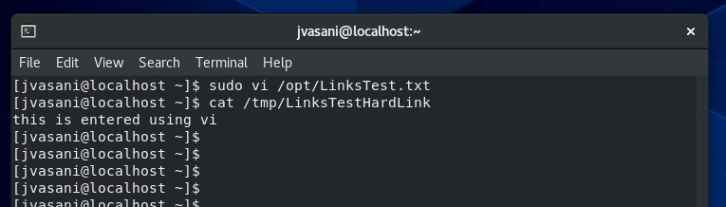
5. Create a symlink to /tmp/LinksTest.txt in the root user's home (/root) directory and view the file's contents. **(take a screen shot)** 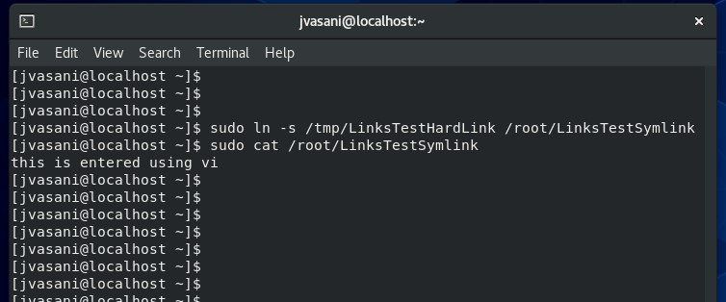
6. Delete the /tmp/LinksTest.txt file, and then attempt to view the file's contents through the /root/LinksTest.txt symlink. (**take a screenshot)** 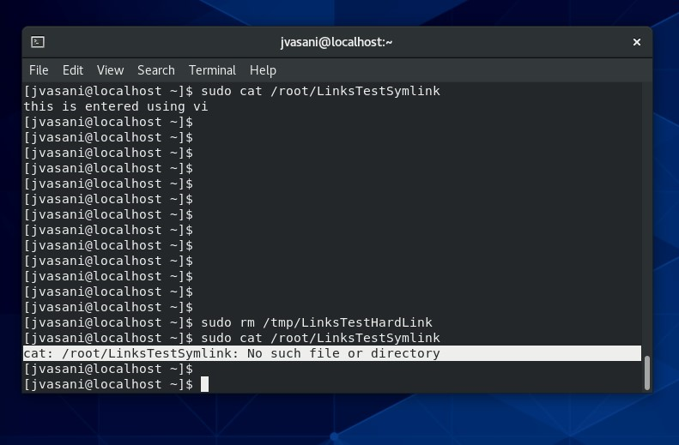
7. Create a directory from root calls /systeminfo **(take screenshot)** 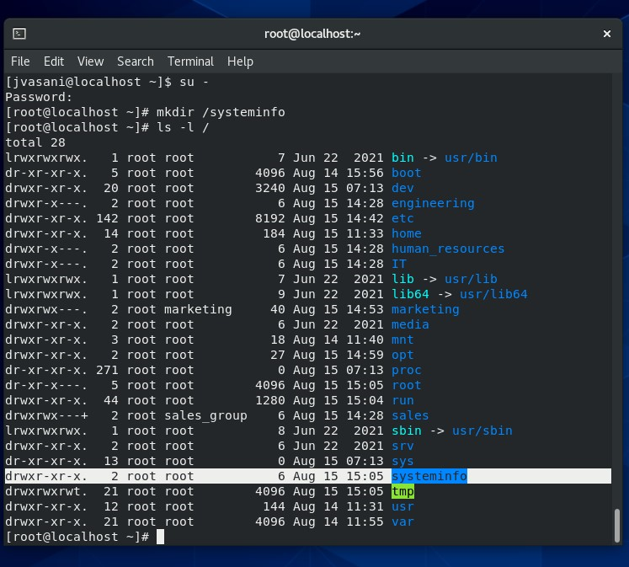
8. Use the following command to DOCUMENT information about your Linux system. Redirect ALL the output to files (stored in the /systeminfo directory : > /systeminfor/<filename>
   1. df,
   2. du,
   3. cat /proc/cpuinfo, **(take a screenshot)** 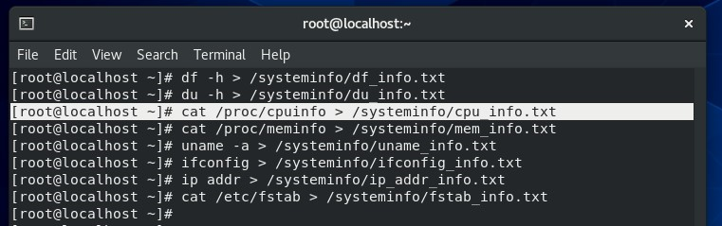
   4. cat /proc/meminfo, (**take a screenshot)** 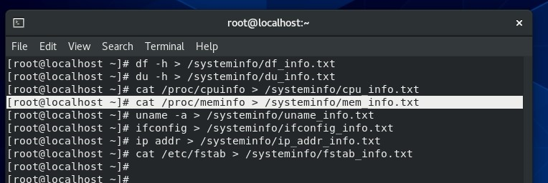
   5. uname –a
   6. ifconfig
   7. ip addr
   8. cat /etc/fstab**, (take a screenshot)** 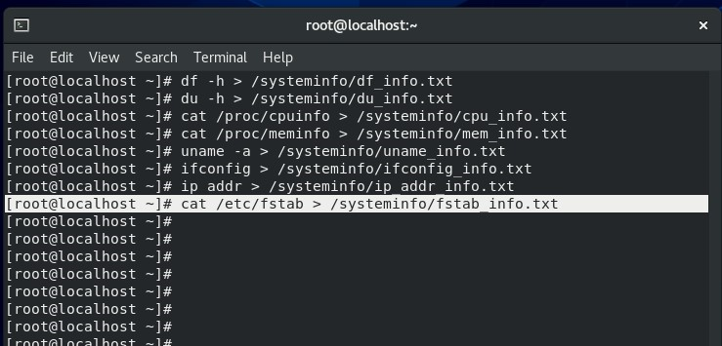
9. REMEMBER TO OUTPUT THESE TO FILES in the /systeminfo directory.
10. List the content of the /systeminfo directory to see the text files created **(take a screenshot)** 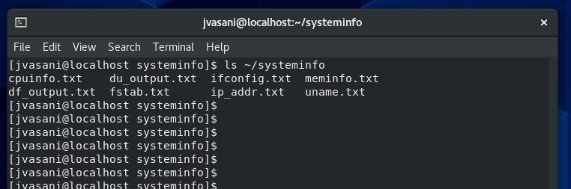
11. Use CAT to take look at these file. $cat /systeminfo/cpudata.txt | more **(take a screenshot)** 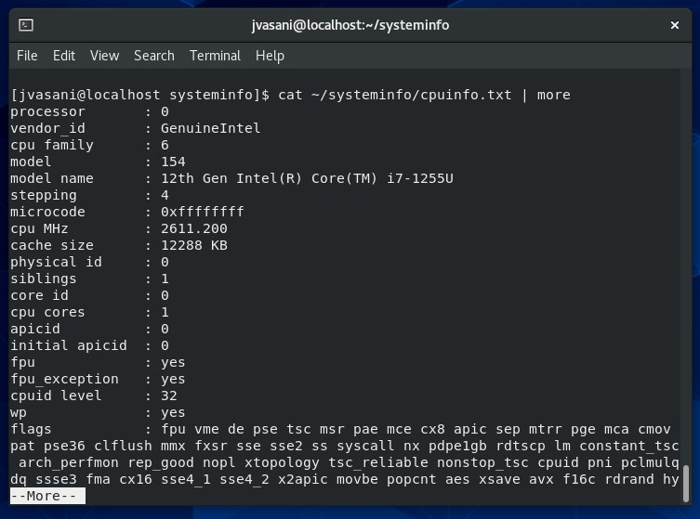
12. Use a combination of ps and grep to display process information about any particular process process**. (take a screenshot)** 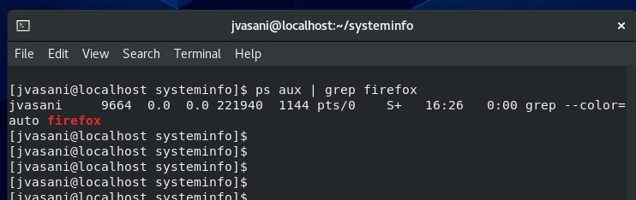
13. **Managing Disk and File Systems : add a new disk to your Linux VM in VMWARE**
    1. Use Fdisk to view the disk info of the newly added disk (**take a screenshot)** 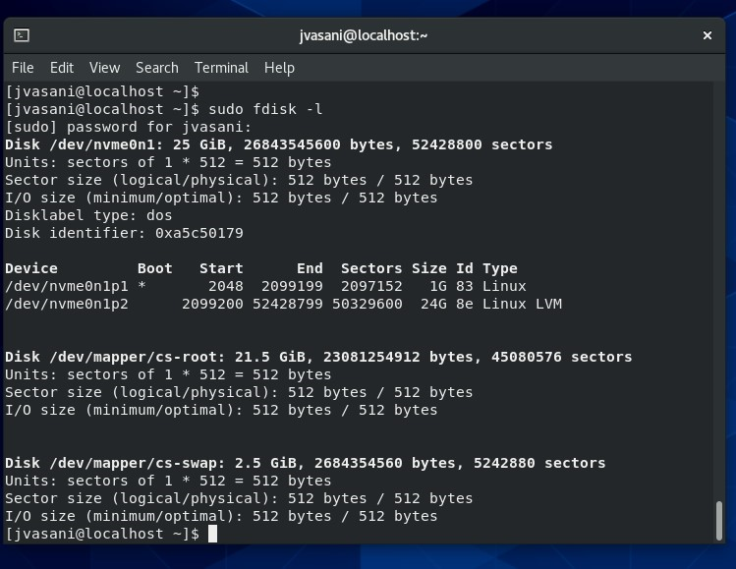
    2. Use Fdisk to make the disk available for use by creating a new primary partition using this disk (ensure that the disk type is LVM or Type 8e **. (take a screenshot)** 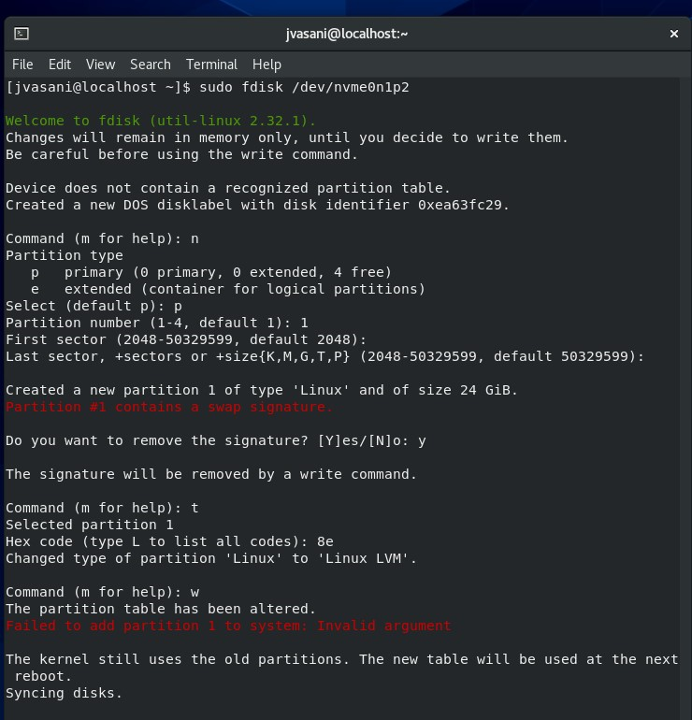
    3. Use **pvcreate** to create the physical volume of the newly create primary partition. **(take a screenshot)**
    4. Display the volume using **pvdisplay (take a screenshot**)
    5. Create a volume group **(take a screenshot)**
    6. Create a logical volume using 50% of the free space and add it to the volume group you just created. **(take a screenshot)**
    7. Format the volume using mkfs.xfs **(take a screenshot)**
    8. Mount the violume
    9. Use the mount command to show the mounted volume. **(take a screenshot)**
    10. Permanently add the disk to the linux OS so that it survives a reboot. **(take a screenshot)**
    11. Use $cat to display the fstab entries showing the newly added disk **(take a screenshot)**
14. Managing File Permissions

**Exercise 1: Basic File Permissions**

mkd

Inside the "chmod_exercises" directory, create three files: "file1.txt," "file2.txt," and "file3.txt."

Set the following permissions on each file:

"file1.txt": Owner - read and write, Group - read, Others - no permissions.

"file2.txt": Owner - read and execute, Group - write, Others - no permissions.

"file3.txt": Owner - read, write, and execute, Group - read and execute, Others - read and execute.

Check the permissions using ls -l and verify if they are correctly set. **(take a screenshot)** 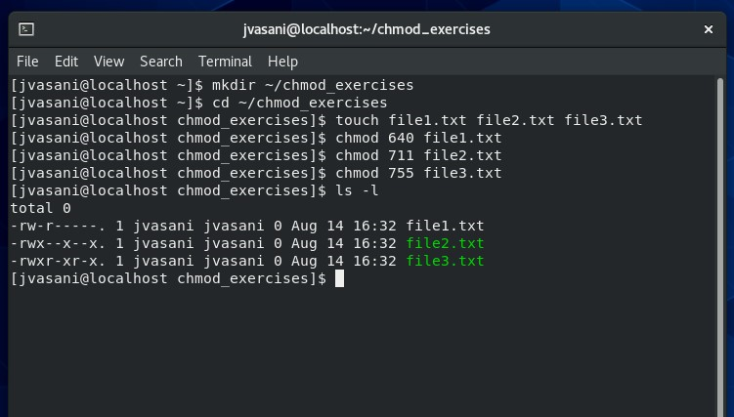

**Exercise 2: Advanced File Permissions**

Inside the "chmod_exercises" directory, create a **new subdirectory** named "secure_dir."

Set the following permissions on "secure_dir":

Owner - read, write, and execute.

Group - read and execute.

Others - no permissions.

**(take a screenshot)** 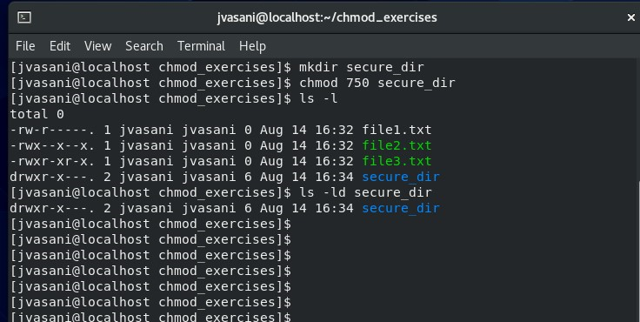

Create a new file named "secret_file.txt" inside the "secure_dir" directory and set the permissions as follows:

Owner - read and write.

Group - no permissions.

Others - no permissions.

**Create a new user named "testuser" on the system.**

**Add "testuser" to the group that owns "secure_dir."**

Verify that "testuser" can access "secure_dir" but cannot read or modify "secret_file.txt." :Do this by loggin in as testuser, going into the directory, then try modify the file by adding data to it with a command such as $echo ‘Adding 1 more line !’ >> secure_file.txt **(take a screenshot)** 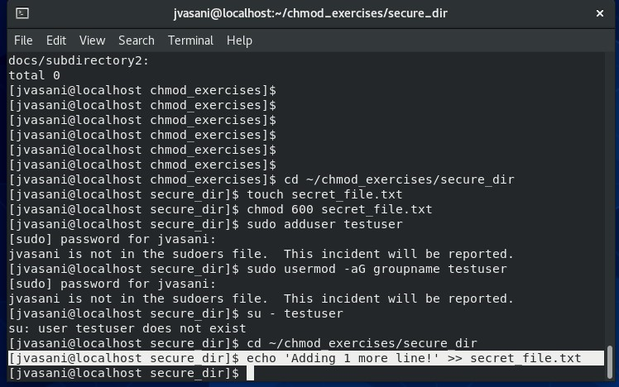

**Exercise 3: Using Numeric Notation**

Inside the "chmod_exercises" directory, create a new file named "numeric_perms.txt."

**Use numeric notation to set the permissions** on "numeric_perms.txt" to the following:

Owner - read, write, and execute.

Group - read and execute.

Others - read only.

**(take a screenshot)** 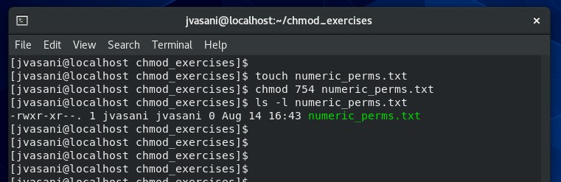

Check the permissions using ls -l and confirm if they are correctly set.

**(take a screenshot)** 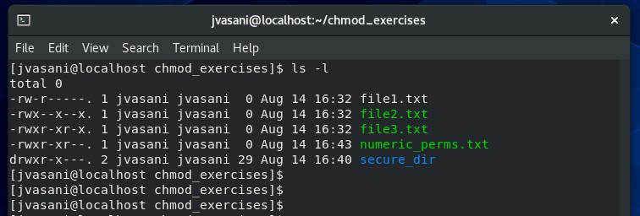

**Exercise 4: Changing Permissions**

Inside the "chmod_exercises" directory, create a new file named "change_me.txt" and set the permissions to allow read and write for the owner, group, and others.

**(take a screenshot)** 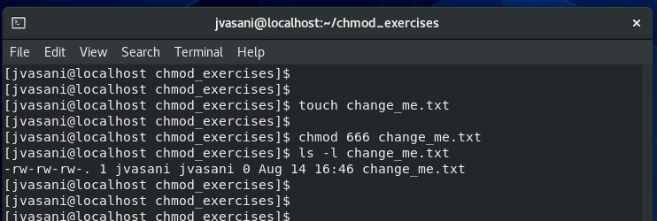

Use the chmod command to change the permissions on "change_me.txt" to allow execute permission for the owner and group while revoking all permissions for others.

**(take a screenshot)** 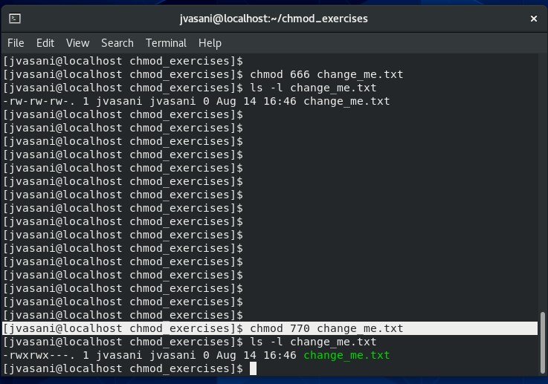

Verify the changes using ls -l and make sure only the owner and group can execute the file.

**Exercise 5: Recursive Permissions**

Inside the "chmod_exercises" directory, create a subdirectory named "docs."

Inside the "docs" directory, **create several files and subdirectories**. 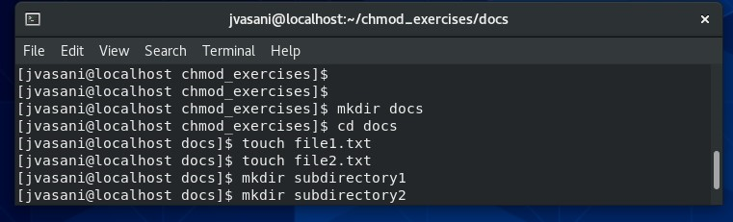

Set appropriate permissions on the "docs" directory so that:

All files have read and write permissions for the owner and group but no permissions for others using the chmod with the –R option : **(take a screenshot)** 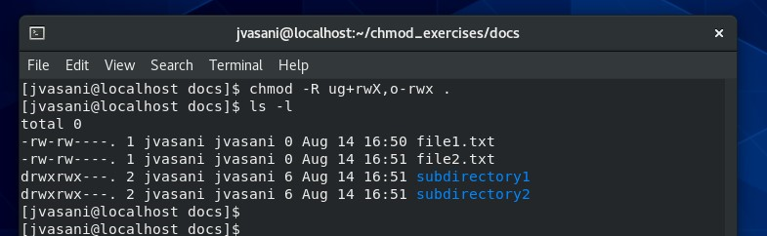

All directories have read, write, and execute permissions for the owner and group but no permissions for others. using the chmod with the –R option :

**(take a screenshot)** 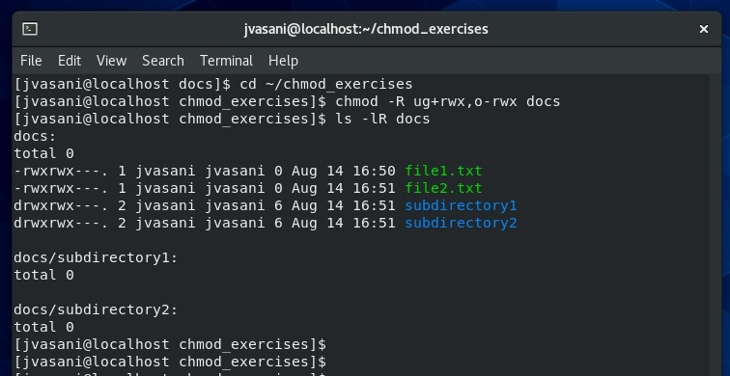

Use the chmod command with the "-R" option to recursively set the permissions on the "docs" directory and its contents as indicated above

.

Verify the permissions using ls -lR to check that the permissions were correctly applied.

END OF EXCERSISES